Classification tree

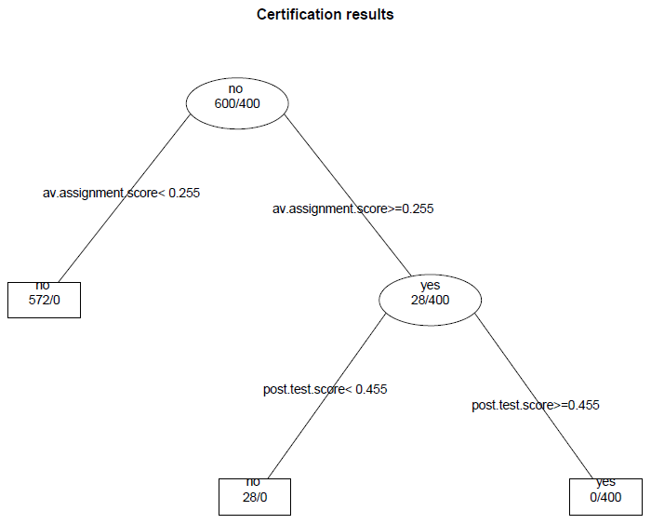

Output to create classification tree

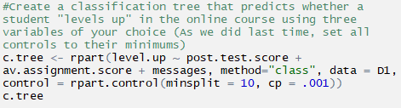

We can then use this model to generate predicted values and estimate the error in the model, both false positives and false negatives.

